# Rail Project Introduction

Purpose: create a collection of data about Game of Thrones.

For this project, the data sources will be:

* TV Maze API: <http://api.tvmaze.com/>
* API Of Ice and Fire: <https://anapioficeandfire.com/>

**TV Maze API**: API to provide information to websites about TV Shows. The end points used for this project will be:

<http://api.tvmaze.com/shows/82/seasons>*:* based on Game of Thrones Id (82), it will retrieve the information about the seasons of the show. This information will be used to construct the Seasons table (columns on the image below).

[http://api.tvmaze.com/seasons/<season_id>/episodes](http://api.tvmaze.com/seasons/%3cseason_id%3e/episodes): based on each Season Id, it will retrieve the information about the episodes of each season. This information will be used to construct the Episodes table (columns on the image below).

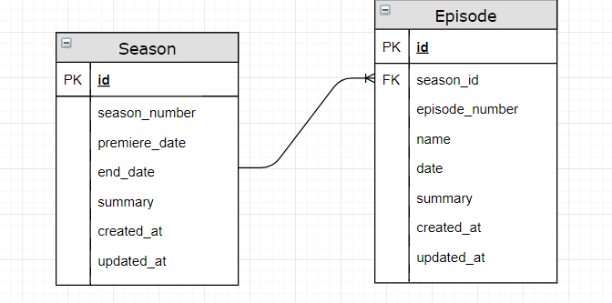

**API of Ice and Fire**: this API provides information about the universe of Ice and Fire. The end points used for this project will be:

<https://anapioficeandfire.com/api/books>: from this end point, the information about each book will be retrieved and it will be used to construct the table Books and table Characters.

<https://anapioficeandfire.com/api/characters>: from previous end point, this end point will be used to create a table Characters with the characters of each book. Both tables will be related thru a join table called Stories, that will make the connection between books and characters.

